**Microprocessor and Computer Architecture**

**UE21CS251B**

**4th Semester, Academic Year 2022-23**

Date:

|  |  |  |
| --- | --- | --- |
| Name: Nikhil Girish | SRN: PES2UG21CS334 | Section: F |

Week#____2_______ Program Number: ____1___

Title of the Program

**Write a program in ARM7TDMI-ISA to copy a block of N data items from Location A to Location B.**

**a. Use Full word (.word directive)**

**b. Use Half word(.hword directive)**

**c. Use Byte wise (.Byte directive)**

1. ARM Assembly Code:

a:

.data

a: .word 10,20,30,40,50,60,70,80,90,100

b: .word 0,0,0,0,0,0,0,0,0,0

.text

LDR R0,=a

LDR R1,=b

MOV R4,#0

l1:

LDR R3,[R0]

STR R3,[R1]

ADD R0,R0,#4

ADD R1,R1,#4

ADD R4,R4,#1

CMP R4, #10

BNE l1

SWI 0x011

.end

b:

.data

a: .hword 1,2,3,4,5,6,7,8,9,10

b: .hword 0,0,0,0,0,0,0,0,0,0

.text

LDRH R0,=a

LDRH R1,=b

MOV R4,#1

l1:

LDRH R3,[R0]

STRH R3,[R1]

ADD R0,R0,#2

ADD R1,R1,#2

ADD R4,R4,#1

CMP R4, #11

BNE l1

SWI 0x011

c:

.data

a: .byte 1,2,3,4,5,6,7,8,9,10

b: .byte 0,0,0,0,0,0,0,0,0,0

.text

LDR R0,=a

LDR R1,=b

MOV R4,#1

l1:

LDRB R3,[R0]

STRB R3,[R1]

ADD R0,R0,#1

ADD R1,R1,#1

ADD R4,R4,#1

CMP R4, #11

BNE l1

SWI 0x011

1. Output Screen Shots (Three)

The output should be verified for word, half word, byte

Word:

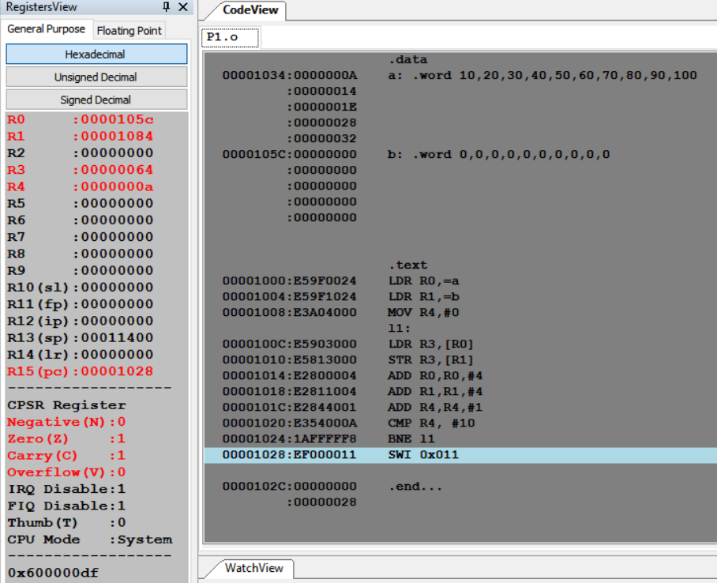

Half-word:

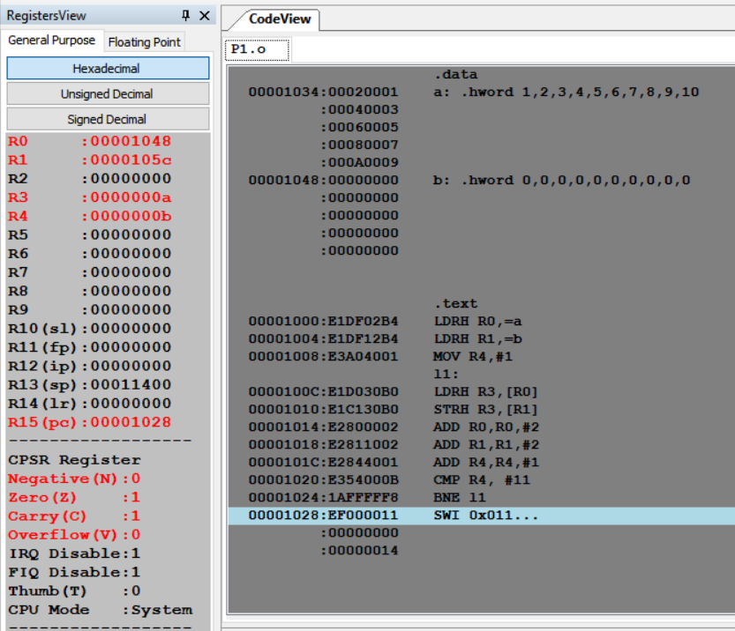

Byte:

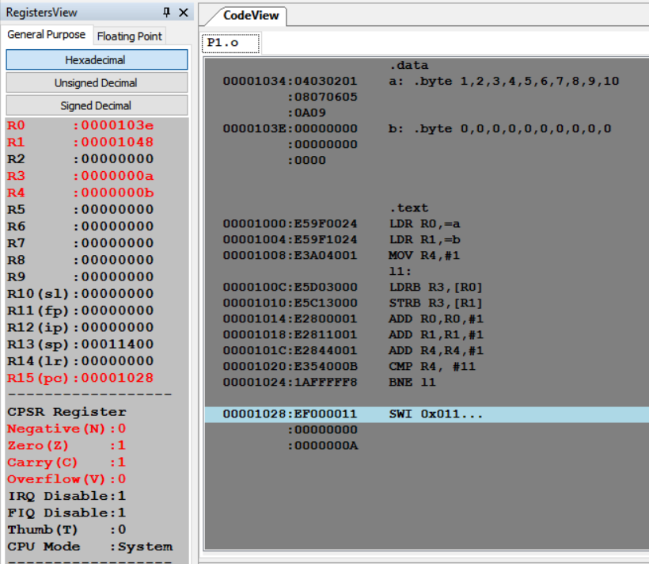

**Microprocessor and Computer Architecture**

**UE21CS251B**

**4th Semester, Academic Year 2022-23**

Date:

|  |  |  |
| --- | --- | --- |
| Name: Nikhil Girish | SRN: PES2UG21CS334 | Section: F |

Week#____2_______ Program Number: ____2___

Title of the Program

**Write a program in ARM7TDMI-ISA to find the sum of N data items in the memory. Store the result in the memory location.**

**a. Use Full word (.word directive)**

**b. Use Half word(.hword directive)**

**c. Use Byte wise (.Byte directive)**

I.ARM Assembly Code

a:

.data

a: .word 10,20,30,40,50,60,70,80,90,100

b: .word 0

.text

LDR R0,=a

LDR R1,=b

MOV R4,#0

MOV R5,#0

l:

LDR R2,[R0]

LDR R3,[R1]

ADD R4,R2,R3

STR R4,[R1]

ADD R0,R0,#4

ADD R5,R5,#1

CMP R5, #10

BNE l

SWI 0x011

b:

.data

a: .hword 10,20,30,40,50,60,70,80,90,100

b: .hword 0

.text

LDR R0,=a

LDR R1,=b

MOV R4,#0

MOV R5,#0

l:

LDRH R2,[R0]

LDRH R3,[R1]

ADD R4,R2,R3

STRH R4,[R1]

ADD R0,R0,#2

ADD R5,R5,#1

CMP R5, #10

BNE l

SWI 0x011

c:

.data

a: .byte 10,20,30,40,50,60,70,80,90,100

b: .byte 0

.text

LDR R0,=a

LDR R1,=b

MOV R4,#0

MOV R5,#0

l:

LDRB R2,[R0]

LDRB R3,[R1]

ADD R4,R2,R3

STRB R4,[R1]

ADD R0,R0,#1

ADD R5,R5,#1

CMP R5, #10

BNE l

SWI 0x011

II. Output Screen Shots (Three)

The output should be verified for word, half word, byte

Word:

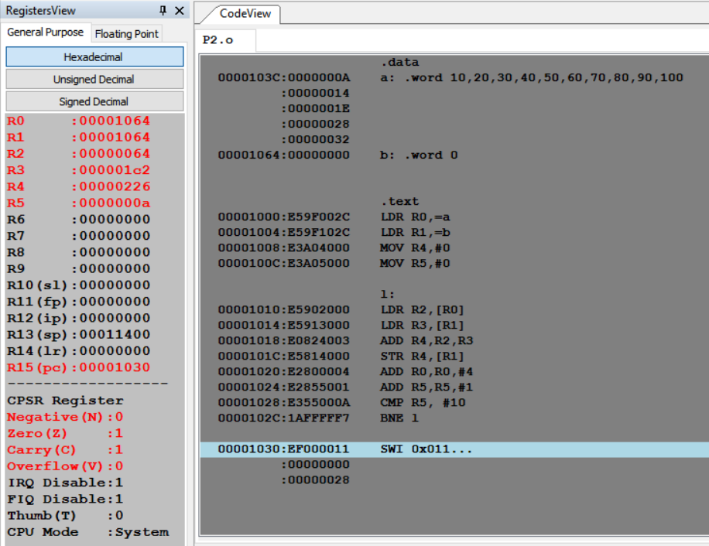

Half-word:

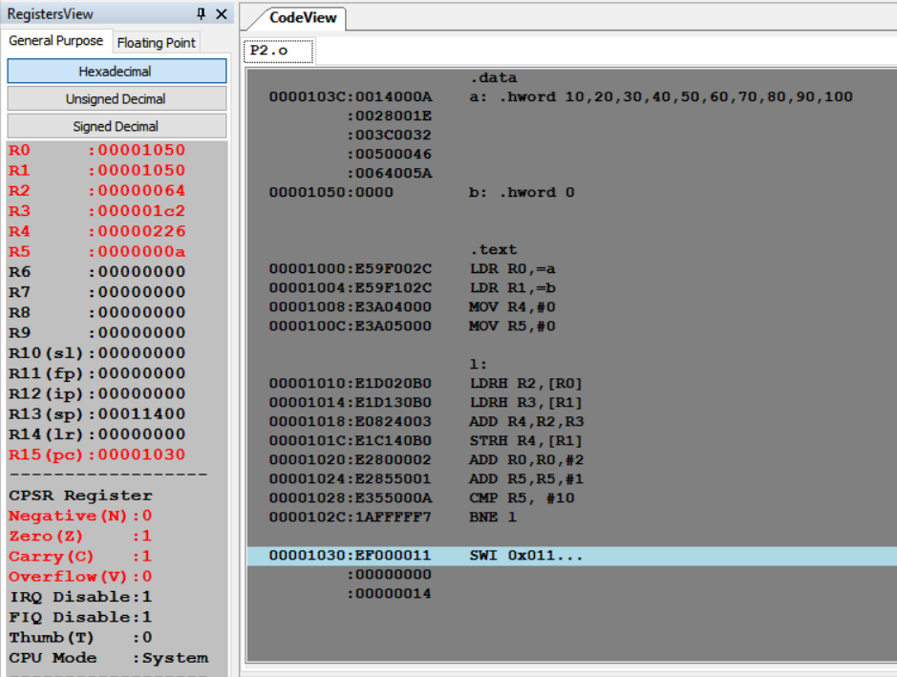

Byte:

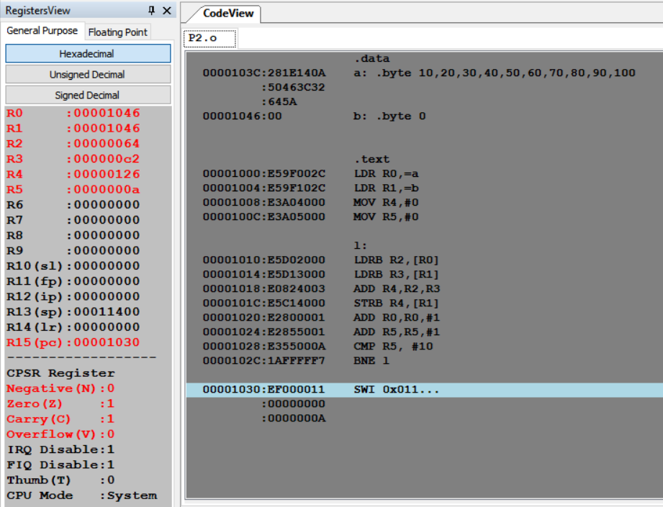

**Microprocessor and Computer Architecture**

**UE21CS251B**

**4th Semester, Academic Year 2022-23**

Date:

|  |  |  |
| --- | --- | --- |
| Name: Nikhil Girish | SRN: PES2UG21CS334 | Section: F |

Week#____2_______ Program Number: ____3___

Title of the Program

**Write a program in ARM7TDMI-ISA to find the sum of N natural numbers. Store the result in the memory location.**

I.ARM Assembly Code:  
.data

a: .byte 1,2,3,4,5,6,7,8,9,10

b: .byte 0

.text

LDR R0,=a

LDR R1,=b

MOV R4,#0

MOV R5,#0

l:

LDRB R2,[R0]

LDRB R3,[R1]

ADD R4,R2,R3

STRB R4,[R1]

ADD R0,R0,#1

ADD R5,R5,#1

CMP R5, #10

BNE l

SWI 0x011

II. Output Screen Shots (One):

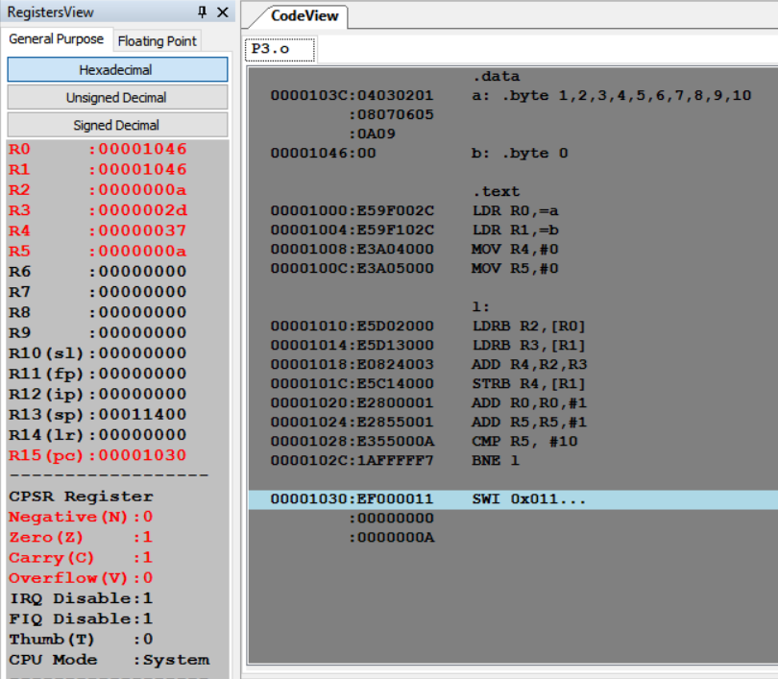

**Microprocessor and Computer Architecture**

**UE21CS251B**

**4th Semester, Academic Year 2022-23**

Date:

|  |  |  |
| --- | --- | --- |
| Name: Nikhil Girish | SRN: PES2UG21CS334 | Section: F |

Week#____2_______ Program Number: ____4___

Title of the Program

**Write a program in ARM7TDMI-ISA to find the product of two 32bit numbers using barrel shifter.**

I.ARM Assembly Code:

.data

a: .word -4

b: .word 9

.text

LDR R0, =a

LDR R0, [R0]

LDR R1, =b

LDR R1, [R1]

MOV R2, #0

MOV R3, #0

l:

    CMP R0, #0

    BEQ end

    TST R0, #1

    BEQ l1

    ADD R3, R3, R1, LSL R2

l1:

    MOV R0, R0, LSR #1

    ADD R2, R2, #1

    B l

end:

SWI 0x011

II. Output Screen Shot (One):

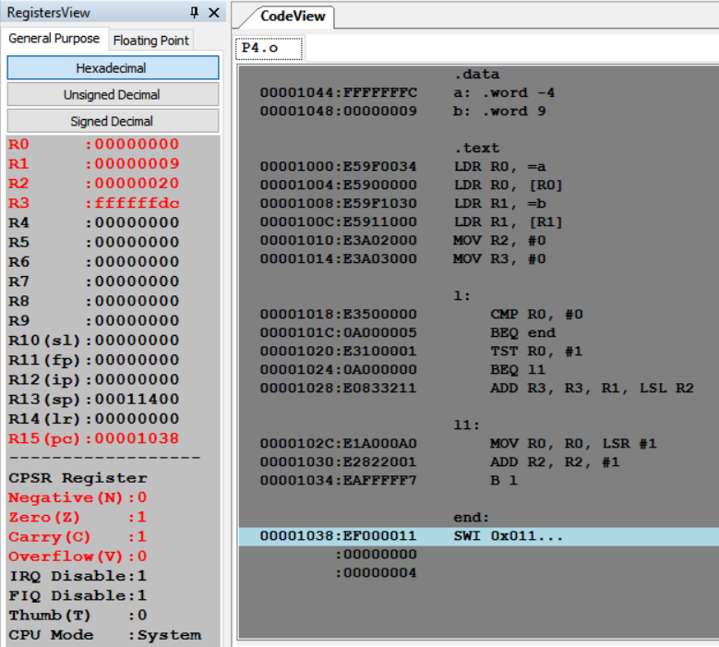

**Microprocessor and Computer Architecture**

**UE21CS251B**

**4th Semester, Academic Year 2022-23**

Date:

|  |  |  |
| --- | --- | --- |
| Name: Nikhil Girish | SRN: PES2UG21CS334 | Section: F |

Week#____2_______ Program Number: ____5___

Title of the Program

**Convert the following statement in C language into an ALP using ARM7TDMI – ISA.**

**IF([A]==[B]) then C=[A]+[B];**

**ELSE IF ([B]==[C]) D=[A]-[B];**

**ELSE E=[A]*[B]**

**Where A,B C, D & E are memory locations.**

I.ARM Assembly Code:

.data

a: .word 2

b: .word 3

c: .word 4

d: .word 0

e: .word 0

.text

LDR R0, =a

LDR R1, =b

LDR R2, =c

LDR R3, =d

LDR R4, =e

LDR R0, [R0]

LDR R1, [R1]

LDR R5, [R2]

TEQ R0, R1

BEQ l

TEQ R1, R5

BEQ l1

MUL R6, R0, R1

STR R6, [R4]

B end

l:

    ADD R6, R0, R1

    STR R6, [R2]

    B end

l1:

    SUB R6, R0, R1

    STR R6, [R3]

    B end

end:

SWI 0x011

II. Output Screen Shot (One):

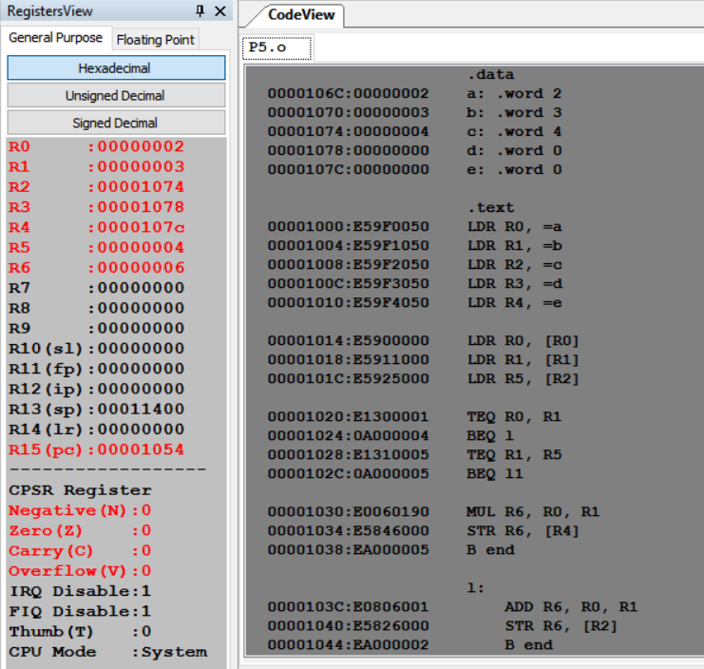

**Microprocessor and Computer Architecture**

**UE21CS251B**

**4th Semester, Academic Year 2022-23**

Date:

|  |  |  |
| --- | --- | --- |
| Name: Nikhil Girish | SRN: PES2UG21CS334 | Section: F |

Week#____2_______ Program Number: ____6__

Title of the Program

**Write a program in ARM7TDMI-ISA to find the factorial of a number.**

I.ARM Assembly Code:

.data

a: .word 7

.text

LDR R0,=a

LDR R0, [R0]

MOV R1,#1

l:

    MUL R1,R0,R1

    SUBS R0,R0,#1

    BNE l

SWI 0x011

II. Output Screen Shot (One):  
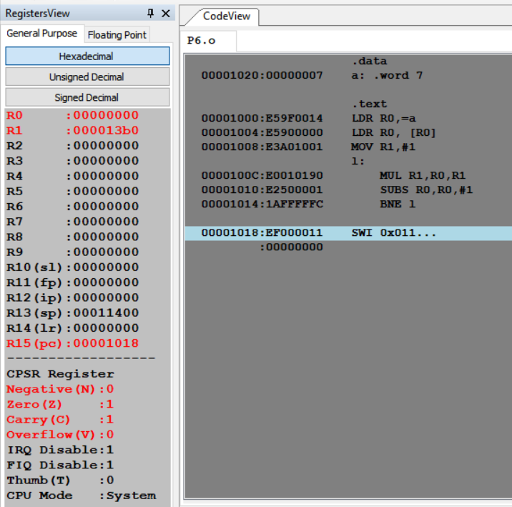

**Disclaimer:**

* The programs and output submitted is duly written, verified and executed by me.
* I have not copied from any of my peers nor from the external resource such as internet.
* If found plagiarized, I will abide with the disciplinary action of the University.

Signature: 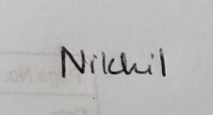

Name: Nikhil Girish

SRN: PES2UG21CS334

Section: 4F

Date: 28-01-2023